**Multi Domain Example Problem**

This example problem shows vessels growing within two different angio materials with different properties. Additionally, vessels within material 1 deflect on the density gradient between the two materials.

**Geometry**

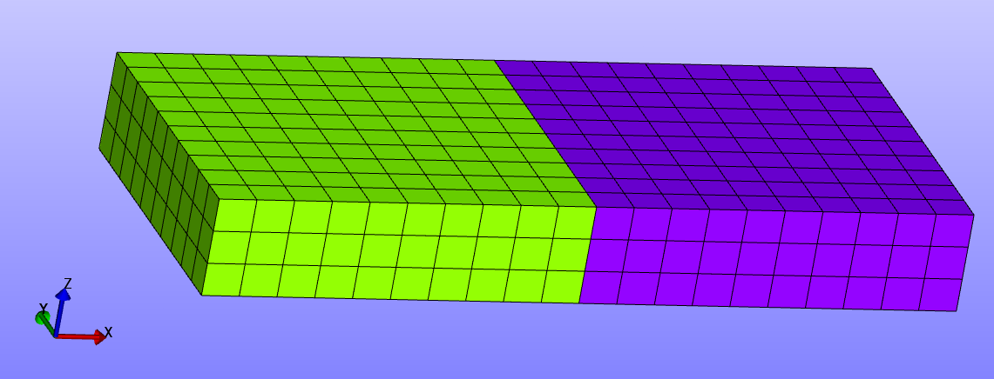

**Boundary Conditions**

-Z face fixed in z direction

Opposite corner nodes fixed in x,y,z.

The density gradient between the materials is viewed by the vessels as occurring in the elements in the green material on the border with the purple material.

**Material(s)**

The green material is an angio material with density of 3. The purple material is an angio material with a density of 5.

**Results**

The rate at which vessel grow vary depending on the material that contains the vessels. Vessels deflect along the density gradient near the boundary between the materials.